**Assignment -IV**

**Develop a website on “Name of Website“ using Flask, CSS, Php & Mysql. which include the following.**

**1. A minimum of 5 connected web pages**

**2. At least one registration page which has been properly validated.**

**3. Only the administrator is able to insert, update, and delete data on that registration page.**

**4. The user or client can perform a search.**

**5. Appropriate formatting**

**User Side**

**Register page**

**<?php**

**include 'config.php';**

**if(isset($_POST['submit'])){**

**$name = mysqli_real_escape_string($conn, $_POST['name']);**

**$email = mysqli_real_escape_string($conn, $_POST['email']);**

**$pass = mysqli_real_escape_string($conn, md5($_POST['password']));**

**$cpass = mysqli_real_escape_string($conn, md5($_POST['cpassword']));**

**$user_type = $_POST['user_type'];**

**$select_users = mysqli_query($conn, "SELECT * FROM `users` WHERE email = '$email' AND password = '$pass'") or die('query failed');**

**if(mysqli_num_rows($select_users) > 0){**

**$message[] = 'user already exist!';**

**}else{**

**if($pass != $cpass){**

**$message[] = 'confirm password not matched!';**

**}else{**

**mysqli_query($conn, "INSERT INTO `users`(name, email, password, user_type) VALUES('$name', '$email', '$cpass', '$user_type')") or die('query failed');**

**$message[] = 'registered successfully!';**

**header('location:login.php');**

**}**

**}**

**}**

**?>**

**<!DOCTYPE html>**

**………**

**<?php**

**if(isset($message)){**

**foreach($message as $message){**

**echo '**

**<div class="message">**

**<span>'.$message.'</span>**

**<i class="fas fa-times" onclick="this.parentElement.remove();"></i>**

**</div>**

**';**

**}**

**}**

**?>**

**……..**

**</html>**

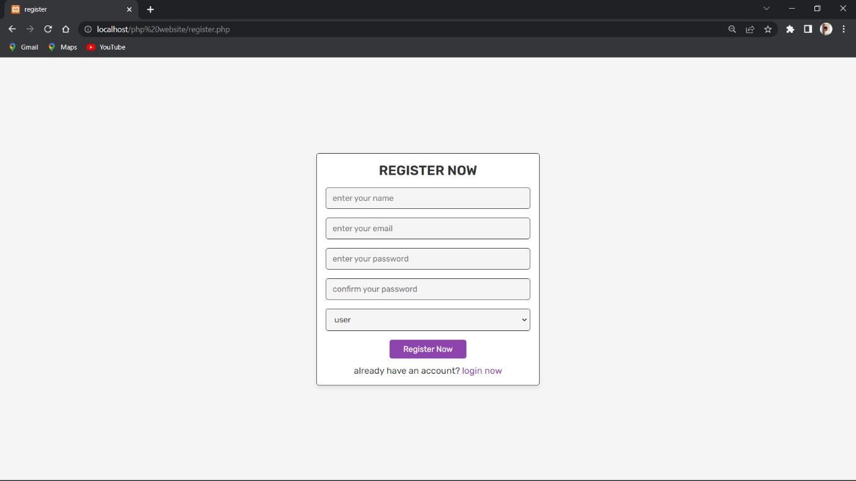

**Login Page**

**<?php**

**include 'config.php';**

**session_start();**

**if(isset($_POST['submit'])){**

**$email = mysqli_real_escape_string($conn, $_POST['email']);**

**$pass = mysqli_real_escape_string($conn, md5($_POST['password']));**

**$select_users = mysqli_query($conn, "SELECT * FROM `users` WHERE email = '$email' AND password = '$pass'") or die('query failed');**

**if(mysqli_num_rows($select_users) > 0){**

**$row = mysqli_fetch_assoc($select_users);**

**if($row['user_type'] == 'admin'){**

**$_SESSION['admin_name'] = $row['name'];**

**$_SESSION['admin_email'] = $row['email'];**

**$_SESSION['admin_id'] = $row['id'];**

**header('location:admin_page.php');**

**}elseif($row['user_type'] == 'user'){**

**$_SESSION['user_name'] = $row['name'];**

**$_SESSION['user_email'] = $row['email'];**

**$_SESSION['user_id'] = $row['id'];**

**header('location:home.php');**

**}**

**}else{**

**$message[] = 'incorrect email or password!';**

**}**

**}**

**?>**

**<!DOCTYPE html>**

**………..**

**<?php**

**if(isset($message)){**

**foreach($message as $message){**

**echo '**

**<div class="message">**

**<span>'.$message.'</span>**

**<i class="fas fa-times" onclick="this.parentElement.remove();"></i>**

**</div>**

**';**

**}**

**}**

**?>**

**……….**

**</html>**

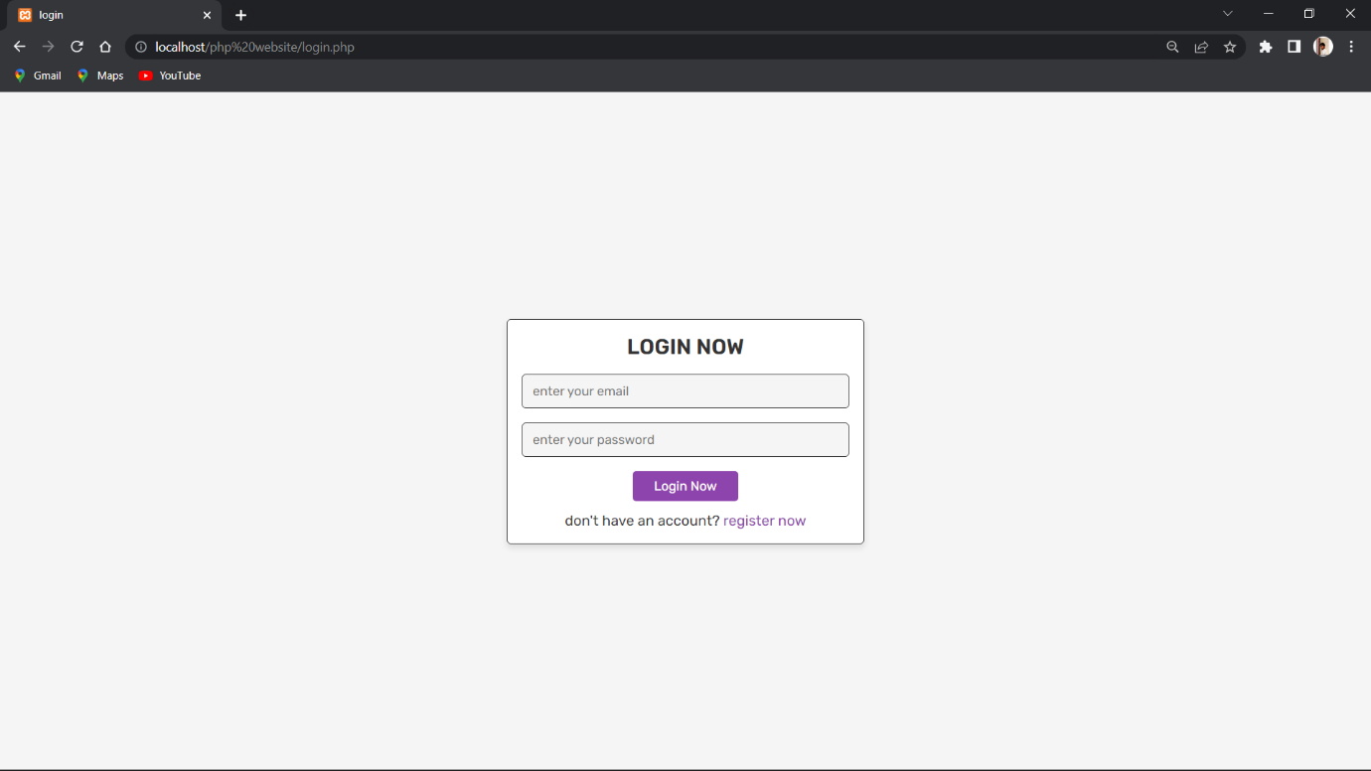

**Header**

**<?php**

**if(isset($message)){**

**foreach($message as $message){**

**echo '**

**<div class="message">**

**<span>'.$message.'</span>**

**<i class="fas fa-times" onclick="this.parentElement.remove();"></i>**

**</div>**

**';**

**}**

**}**

**?>**

**<header class="header">**

**……**

**</header>**

**Home**

**<?php**

**include 'config.php';**

**session_start();**

**$user_id = $_SESSION['user_id'];**

**if(!isset($user_id)){**

**header('location:login.php');**

**}**

**if(isset($_POST['add_to_cart'])){**

**$product_name = $_POST['product_name'];**

**$product_price = $_POST['product_price'];**

**$product_image = $_POST['product_image'];**

**$product_quantity = $_POST['product_quantity'];**

**$check_cart_numbers = mysqli_query($conn, "SELECT * FROM `cart` WHERE name = '$product_name' AND user_id = '$user_id'") or die('query failed');**

**if(mysqli_num_rows($check_cart_numbers) > 0){**

**$message[] = 'already added to cart!';**

**}else{**

**mysqli_query($conn, "INSERT INTO `cart`(user_id, name, price, quantity, image) VALUES('$user_id', '$product_name', '$product_price', '$product_quantity', '$product_image')") or die('query failed');**

**$message[] = 'product added to cart!';**

**}**

**}**

**?>**

**<!DOCTYPE html>**

**……..**

**</html>**



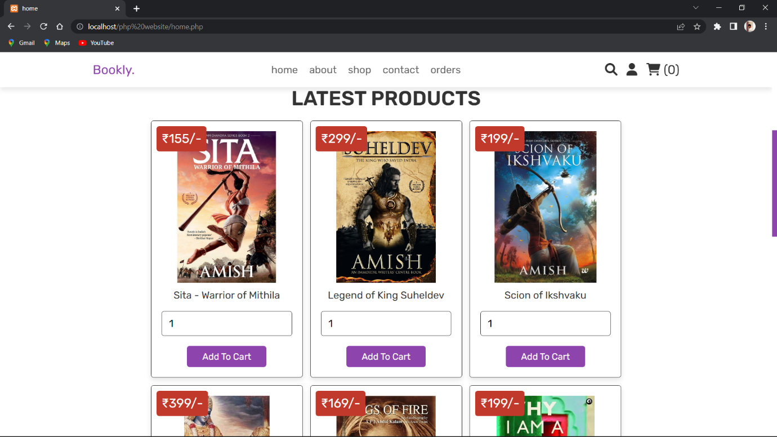

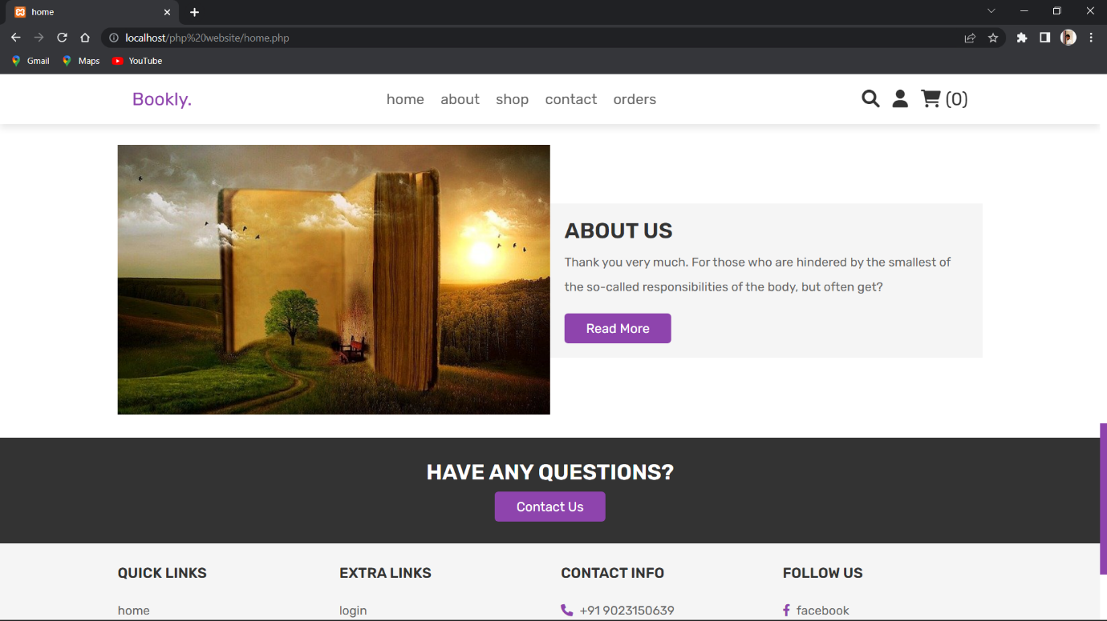

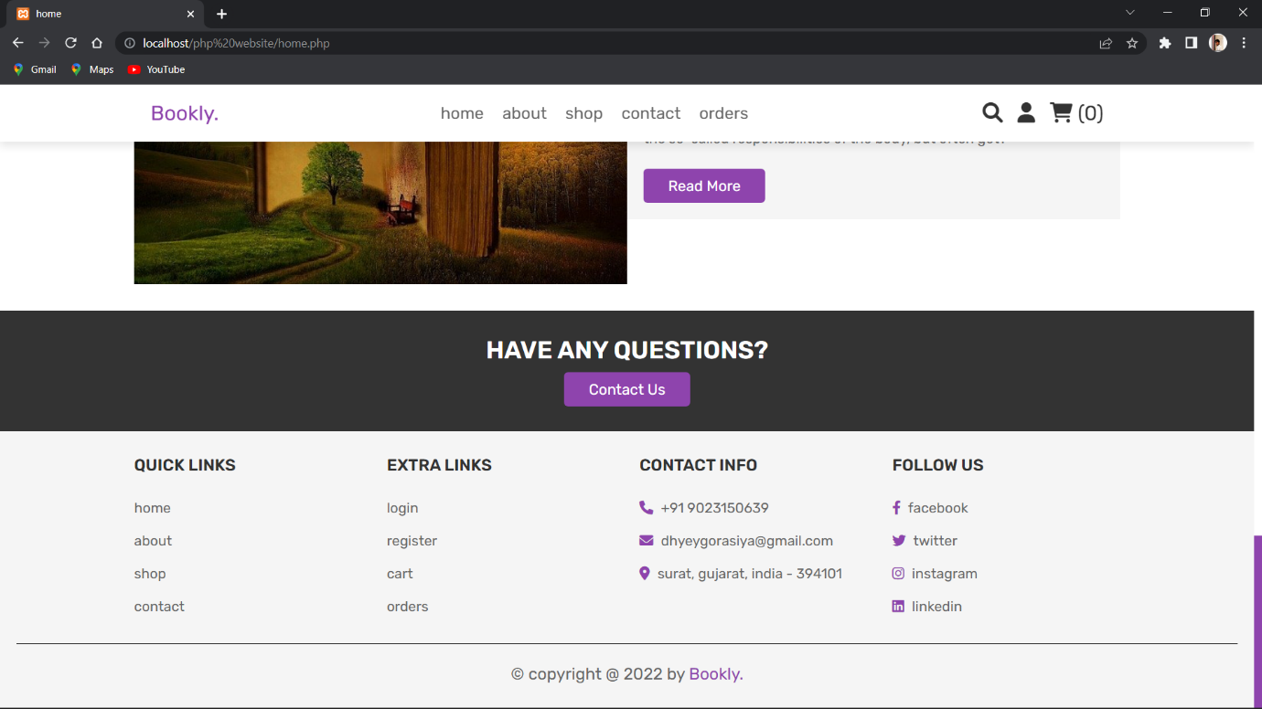

**About**

**<?php**

**include 'config.php';**

**session_start();**

**$user_id = $_SESSION['user_id'];**

**if(!isset($user_id)){**

**header('location:login.php');**

**}**

**?>**

**<!DOCTYPE html>**

**<html lang="en">**

**<head>**

**<meta charset="UTF-8">**

**<meta http-equiv="X-UA-Compatible" content="IE=edge">**

**<meta name="viewport" content="width=device-width, initial-scale=1.0">**

**<title>about</title>**

**<!-- font awesome cdn link -->**

**<link rel="stylesheet" href="https://cdnjs.cloudflare.com/ajax/libs/font-awesome/6.0.0/css/all.min.css">**

**<!-- custom css file link -->**

**<link rel="stylesheet" href="css/style.css">**

**</head>**

**<body>**

**<?php include 'header.php'; ?>**

**<div class="heading">**

**<h3>about us</h3>**

**<p> <a href="home.php">home</a> / about </p>**

**</div>**

**<section class="about">**

**<div class="flex">**

**<div class="image">**

**<img src="images/about-img.jpg" alt="">**

**</div>**

**<div class="content">**

**<h3>why choose us?</h3>**

**<p>It is very important for the customer to pay attention to the adipiscing process. It will happen to the pleasures or here the troubles, by rejecting the birth of the flight, as soon as we receive the pardon by reason of right. Is it acceptable to run away from doing just that?</p>**

**<p>Thank you very much. For those who are hindered by the smallest of the so-called responsibilities of the body, but often get?</p>**

**<a href="contact.php" class="btn">contact us</a>**

**</div>**

**</div>**

**</section>**

**<section class="reviews">**

**<h1 class="title">customer's reviews</h1>**

**<div class="box-container">**

**<div class="box">**

**<img src="images/pic-1.jpg" alt="">**

**<p>WOW!, "Wings Of Fire" is a great book in my life. Thank You to prefer me this awsome book!!! </p>**

**<div class="stars">**

**<i class="fas fa-star"></i>**

**<i class="fas fa-star"></i>**

**<i class="fas fa-star"></i>**

**<i class="fas fa-star"></i>**

**<i class="fas fa-star"></i>**

**</div>**

**<h3>Darshan Balar</h3>**

**</div>**

**<div class="box">**

**<img src="images/pic-2.jpg" alt="">**

**<p>The alchemist book was amazing i recently finished the book and it's give such a peaceful to the mind. And book story was amazing i really like to read this book. This is the book written by paulo coelho.</p>**

**<div class="stars">**

**<i class="fas fa-star"></i>**

**<i class="fas fa-star"></i>**

**<i class="fas fa-star"></i>**

**<i class="fas fa-star"></i>**

**<i class="fas fa-star-half-alt"></i>**

**</div>**

**<h3>Sanket Beladiya</h3>**

**</div>**

**<div class="box">**

**<img src="images/pic-3.jpg" alt="">**

**<p>this book is amazing !! I love this book Chetan bhagat books are always amazing and interesting...💛</p>**

**<div class="stars">**

**<i class="fas fa-star"></i>**

**<i class="fas fa-star"></i>**

**<i class="fas fa-star"></i>**

**<i class="fas fa-star"></i>**

**<i class="fas fa-star"></i>**

**</div>**

**<h3>Meet Barvaliya</h3>**

**</div>**

**<div class="box">**

**<img src="images/pic-4.jpg" alt="">**

**<p>I am very happy with this book, the packaging was great , the book is a best gift for a culture and history lover ..</p>**

**<div class="stars">**

**<i class="fas fa-star"></i>**

**<i class="fas fa-star"></i>**

**<i class="fas fa-star"></i>**

**<i class="fas fa-star-half-alt"></i>**

**</div>**

**<h3>Tejas Devani</h3>**

**</div>**

**<div class="box">**

**<img src="images/pic-5.jpg" alt="">**

**<p>Perfect!! Good HardBounded Book, and Shashi Tharoor is just Great!! Masterpiece for intellectuals..</p>**

**<div class="stars">**

**<i class="fas fa-star"></i>**

**<i class="fas fa-star"></i>**

**<i class="fas fa-star"></i>**

**<i class="fas fa-star"></i>**

**<i class="fas fa-star-half-alt"></i>**

**</div>**

**<h3>Milan Bhakhar</h3>**

**</div>**

**<div class="box">**

**<img src="images/pic-6.jpg" alt="">**

**<p>The book is an excellent read for those people who have a good idea about the Mahabharata and the history of modern Indian politics till the late 1980s.</p>**

**<div class="stars">**

**<i class="fas fa-star"></i>**

**<i class="fas fa-star"></i>**

**<i class="fas fa-star"></i>**

**<i class="fas fa-star"></i>**

**</div>**

**<h3>Navdeep Chothani</h3>**

**</div>**

**</div>**

**</section>**

**<section class="authors">**

**<h1 class="title">greate authors</h1>**

**<div class="box-container">**

**<div class="box">**

**<img src="images/author-1.jpg" alt="">**

**<div class="share">**

**<a href="#" class="fab fa-facebook-f"></a>**

**<a href="#" class="fab fa-twitter"></a>**

**<a href="#" class="fab fa-instagram"></a>**

**<a href="#" class="fab fa-linkedin"></a>**

**</div>**

**<h3>R. K. Narayan</h3>**

**</div>**

**<div class="box">**

**<img src="images/author-2.jpg" alt="">**

**<div class="share">**

**<a href="#" class="fab fa-facebook-f"></a>**

**<a href="#" class="fab fa-twitter"></a>**

**<a href="#" class="fab fa-instagram"></a>**

**<a href="#" class="fab fa-linkedin"></a>**

**</div>**

**<h3>Chetan Bhagat</h3>**

**</div>**

**<div class="box">**

**<img src="images/author-3.jpg" alt="">**

**<div class="share">**

**<a href="#" class="fab fa-facebook-f"></a>**

**<a href="#" class="fab fa-twitter"></a>**

**<a href="#" class="fab fa-instagram"></a>**

**<a href="#" class="fab fa-linkedin"></a>**

**</div>**

**<h3>Shashi Tharoor</h3>**

**</div>**

**<div class="box">**

**<img src="images/author-4.jpg" alt="">**

**<div class="share">**

**<a href="#" class="fab fa-facebook-f"></a>**

**<a href="#" class="fab fa-twitter"></a>**

**<a href="#" class="fab fa-instagram"></a>**

**<a href="#" class="fab fa-linkedin"></a>**

**</div>**

**<h3>Jhumpa Lahiri</h3>**

**</div>**

**<div class="box">**

**<img src="images/author-5.jpg" alt="">**

**<div class="share">**

**<a href="#" class="fab fa-facebook-f"></a>**

**<a href="#" class="fab fa-twitter"></a>**

**<a href="#" class="fab fa-instagram"></a>**

**<a href="#" class="fab fa-linkedin"></a>**

**</div>**

**<h3>Vikram Seth</h3>**

**</div>**

**<div class="box">**

**<img src="images/author-6.jpg" alt="">**

**<div class="share">**

**<a href="#" class="fab fa-facebook-f"></a>**

**<a href="#" class="fab fa-twitter"></a>**

**<a href="#" class="fab fa-instagram"></a>**

**<a href="#" class="fab fa-linkedin"></a>**

**</div>**

**<h3>Amish Tripathi</h3>**

**</div>**

**</div>**

**</section>**

**<?php include 'footer.php'; ?>**

**<!-- custom js file link -->**

**<script src="js/script.js"></script>**

**</body>**

**</html>**

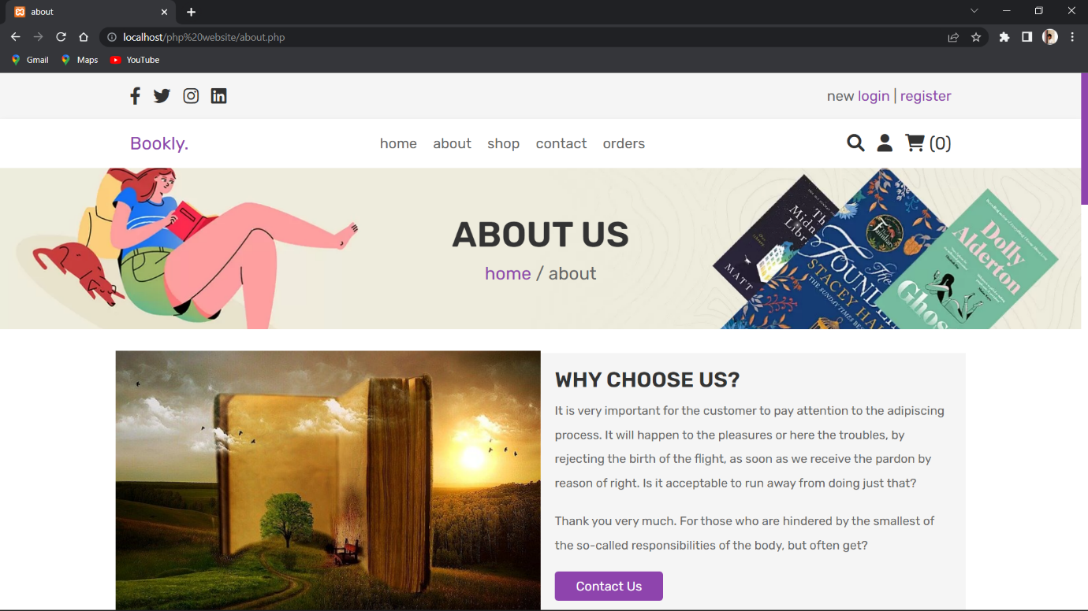

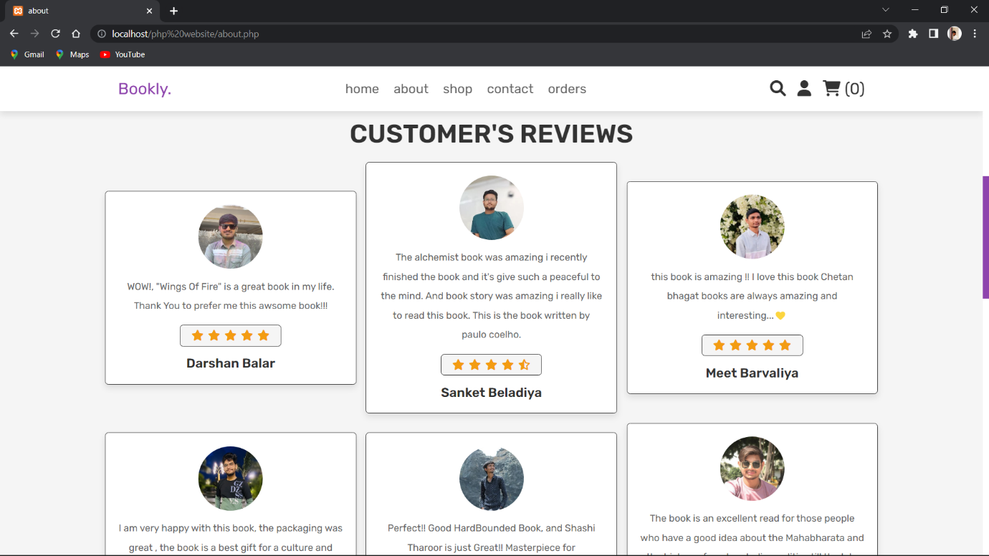

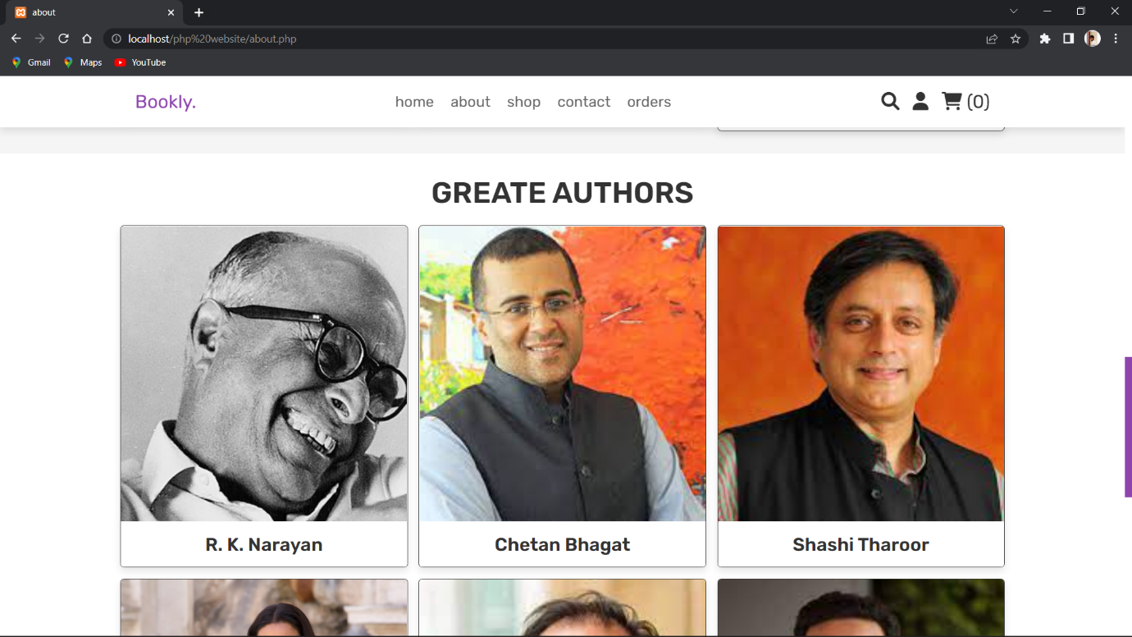

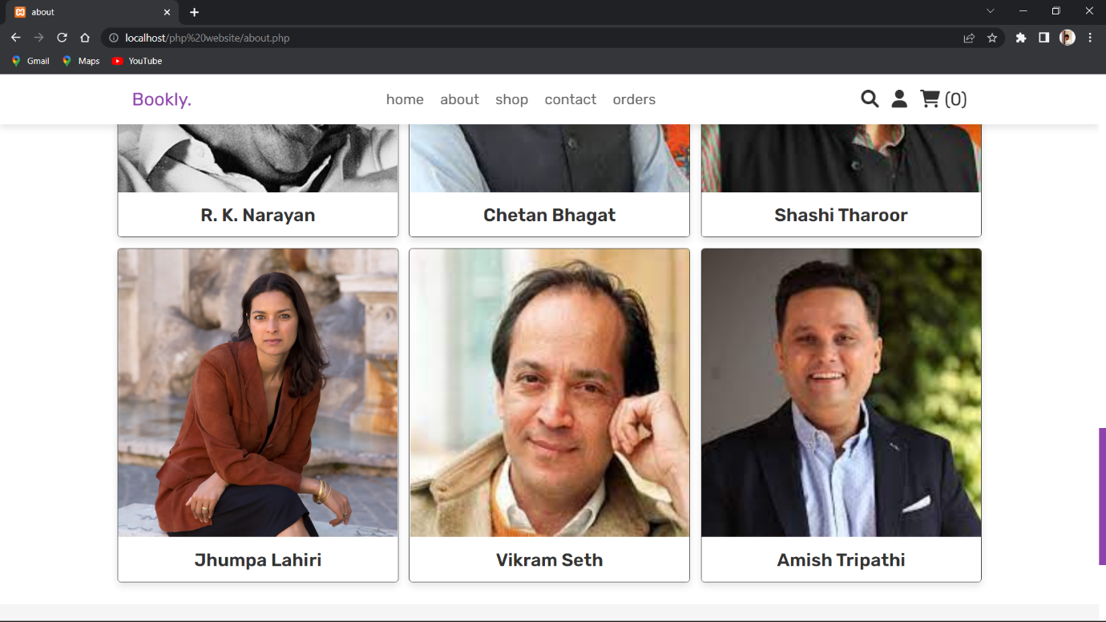

**Shop**

**<?php**

**include 'config.php';**

**session_start();**

**$user_id = $_SESSION['user_id'];**

**if(!isset($user_id)){**

**header('location:login.php');**

**}**

**if(isset($_POST['add_to_cart'])){**

**$product_name = $_POST['product_name'];**

**$product_price = $_POST['product_price'];**

**$product_image = $_POST['product_image'];**

**$product_quantity = $_POST['product_quantity'];**

**$check_cart_numbers = mysqli_query($conn, "SELECT * FROM `cart` WHERE name = '$product_name' AND user_id = '$user_id'") or die('query failed');**

**if(mysqli_num_rows($check_cart_numbers) > 0){**

**$message[] = 'already added to cart!';**

**}else{**

**mysqli_query($conn, "INSERT INTO `cart`(user_id, name, price, quantity, image) VALUES('$user_id', '$product_name', '$product_price', '$product_quantity', '$product_image')") or die('query failed');**

**$message[] = 'product added to cart!';**

**}**

**}**

**?>**

**<!DOCTYPE html>**

**……..**

**</html>**

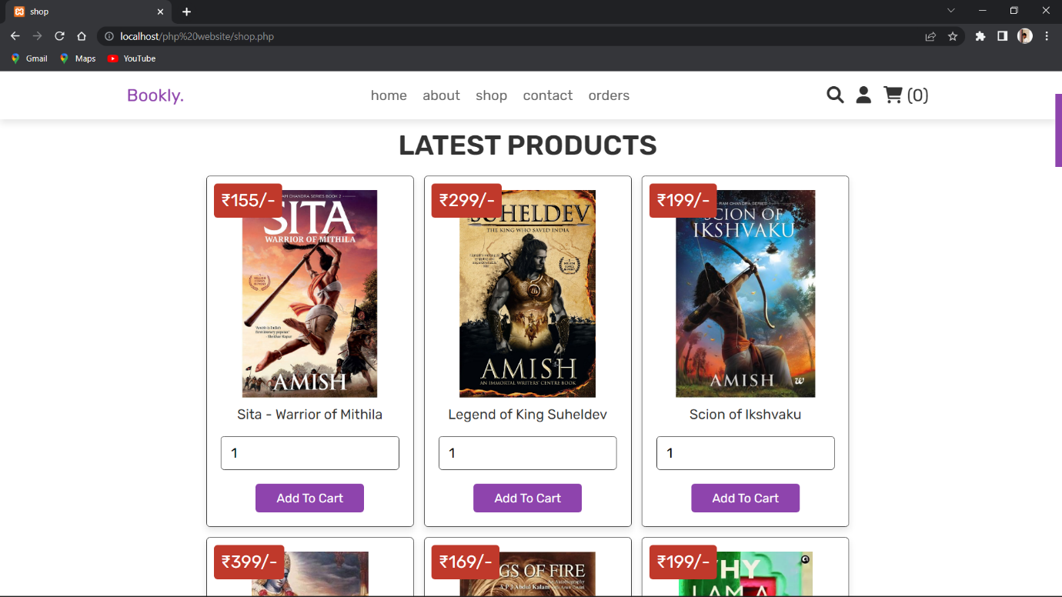

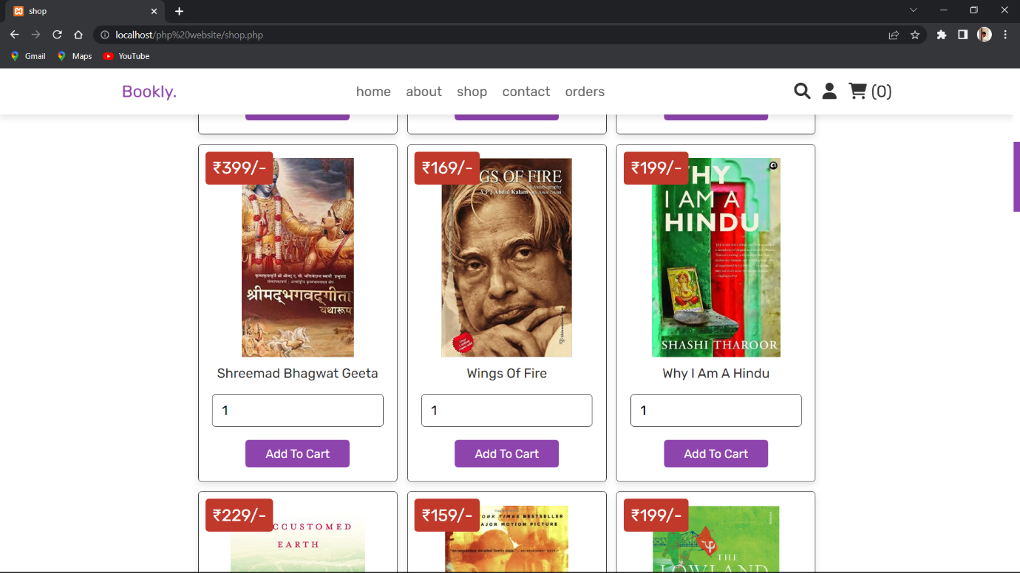

**Contect**

**<?php**

**include 'config.php';**

**session_start();**

**$user_id = $_SESSION['user_id'];**

**if(!isset($user_id)){**

**header('location:login.php');**

**}**

**if(isset($_POST['send'])){**

**$name = mysqli_real_escape_string($conn, $_POST['name']);**

**$email = mysqli_real_escape_string($conn, $_POST['email']);**

**$number = $_POST['number'];**

**$msg = mysqli_real_escape_string($conn, $_POST['message']);**

**$select_message = mysqli_query($conn, "SELECT * FROM `message` WHERE name = '$name' AND email = '$email' AND number = '$number' AND message = '$msg'") or die('query failed');**

**if(mysqli_num_rows($select_message) > 0){**

**$message[] = 'message sent already!';**

**}else{**

**mysqli_query($conn, "INSERT INTO `message`(user_id, name, email, number, message) VALUES('$user_id', '$name', '$email', '$number', '$msg')") or die('query failed');**

**$message[] = 'message sent successfully!';**

**}**

**}**

**?>**

**<!DOCTYPE html>**

**…….**

**</html>**

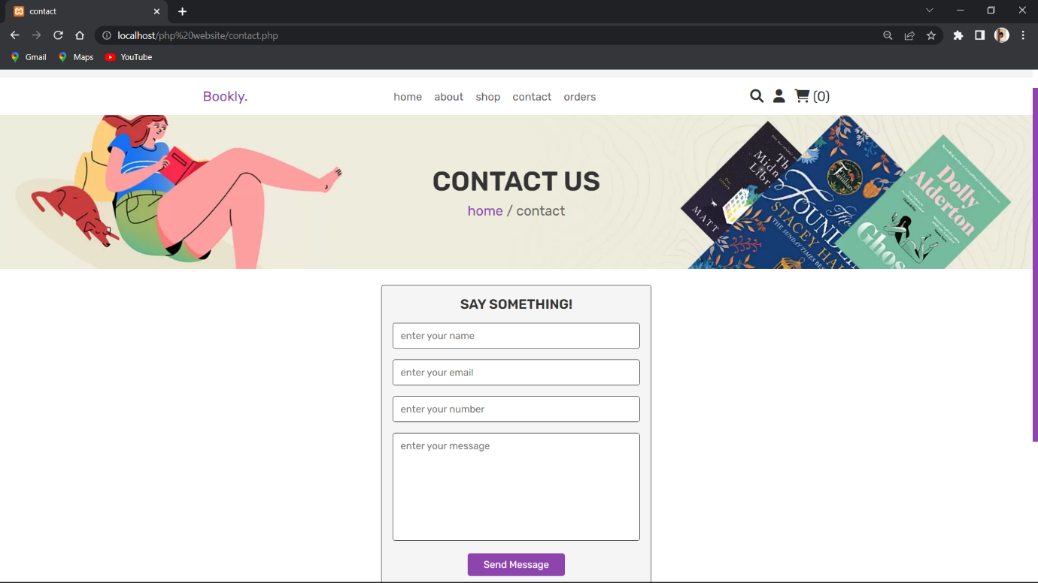

**Orders**

**<?php**

**include 'config.php';**

**session_start();**

**$user_id = $_SESSION['user_id'];**

**if(!isset($user_id)){**

**header('location:login.php');**

**}**

**?>**

**<!DOCTYPE html>**

**………**

**<?php**

**$order_query = mysqli_query($conn, "SELECT * FROM `orders` WHERE user_id = '$user_id'") or die('query failed');**

**if(mysqli_num_rows($order_query) > 0){**

**while($fetch_orders = mysqli_fetch_assoc($order_query)){**

**?>**

**<?php**

**}**

**}else{**

**echo '<p class="empty">no orders placed yet!</p>';**

**}**

**?>**

**</html>**

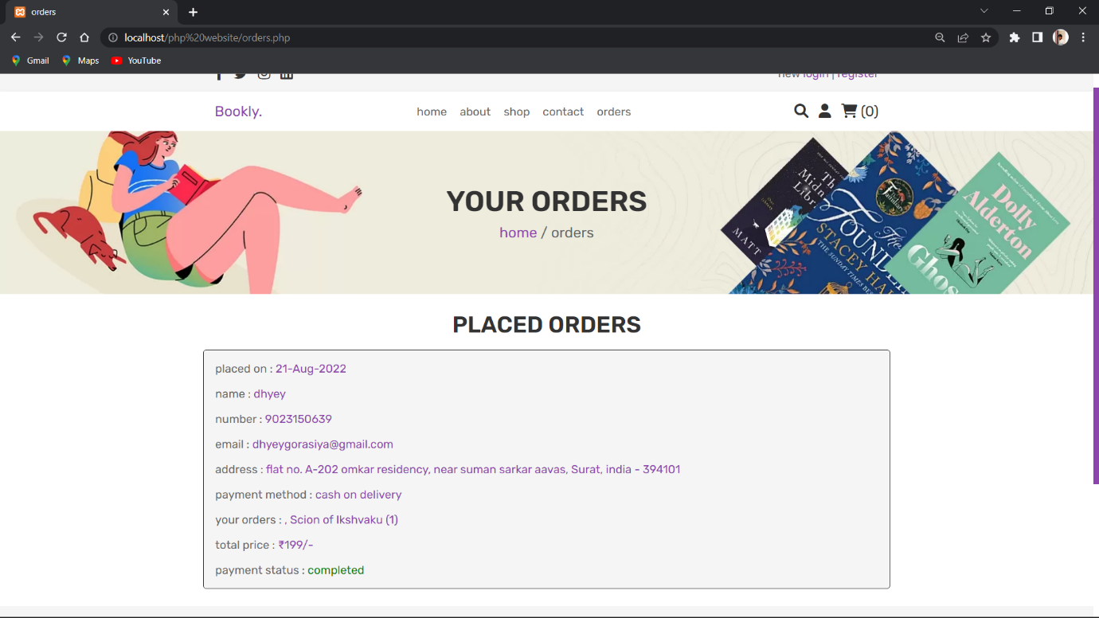

**Search**

**<?php**

**include 'config.php';**

**session_start();**

**$user_id = $_SESSION['user_id'];**

**if(!isset($user_id)){**

**header('location:login.php');**

**};**

**if(isset($_POST['add_to_cart'])){**

**$product_name = $_POST['product_name'];**

**$product_price = $_POST['product_price'];**

**$product_image = $_POST['product_image'];**

**$product_quantity = $_POST['product_quantity'];**

**$check_cart_numbers = mysqli_query($conn, "SELECT * FROM `cart` WHERE name = '$product_name' AND user_id = '$user_id'") or die('query failed');**

**if(mysqli_num_rows($check_cart_numbers) > 0){**

**$message[] = 'already added to cart!';**

**}else{**

**mysqli_query($conn, "INSERT INTO `cart`(user_id, name, price, quantity, image) VALUES('$user_id', '$product_name', '$product_price', '$product_quantity', '$product_image')") or die('query failed');**

**$message[] = 'product added to cart!';**

**}**

**};**

**?>**

**<!DOCTYPE html>**

**…….**

**<?php**

**if(isset($_POST['submit'])){**

**$search_item = $_POST['search'];**

**$select_products = mysqli_query($conn, "SELECT * FROM `products` WHERE name LIKE '%{$search_item}%'") or die('query failed');**

**if(mysqli_num_rows($select_products) > 0){**

**while($fetch_product = mysqli_fetch_assoc($select_products)){**

**?>**

**<?php**

**}**

**}else{**

**echo '<p class="empty">no result found!</p>';**

**}**

**}else{**

**echo '<p class="empty">search something!</p>';**

**}**

**?>**

**</html>**

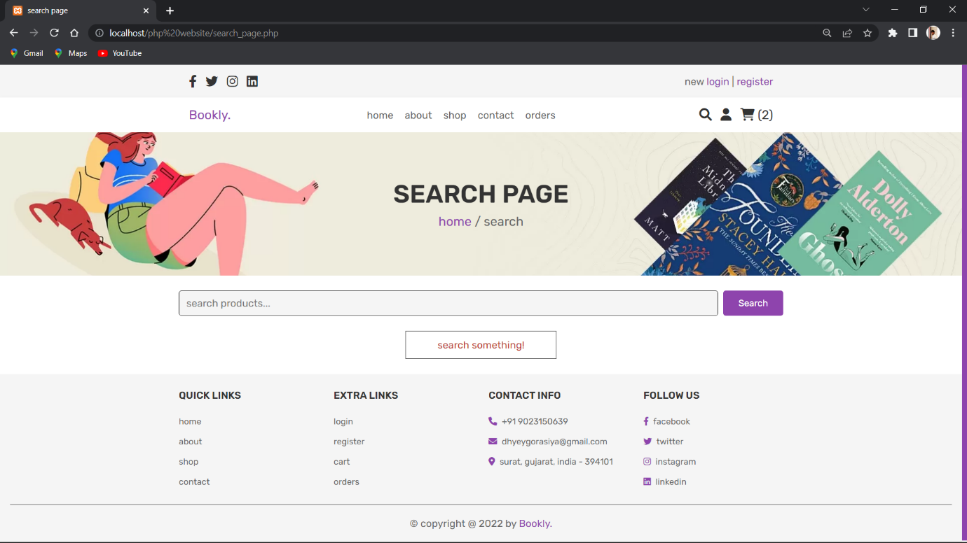

**Add To Cart**

**<?php**

**include 'config.php';**

**session_start();**

**$user_id = $_SESSION['user_id'];**

**if(!isset($user_id)){**

**header('location:login.php');**

**};**

**if(isset($_POST['add_to_cart'])){**

**$product_name = $_POST['product_name'];**

**$product_price = $_POST['product_price'];**

**$product_image = $_POST['product_image'];**

**$product_quantity = $_POST['product_quantity'];**

**$check_cart_numbers = mysqli_query($conn, "SELECT * FROM `cart` WHERE name = '$product_name' AND user_id = '$user_id'") or die('query failed');**

**if(mysqli_num_rows($check_cart_numbers) > 0){**

**$message[] = 'already added to cart!';**

**}else{**

**mysqli_query($conn, "INSERT INTO `cart`(user_id, name, price, quantity, image) VALUES('$user_id', '$product_name', '$product_price', '$product_quantity', '$product_image')") or die('query failed');**

**$message[] = 'product added to cart!';**

**}**

**};**

**?>**

**<!DOCTYPE html>**

**……..**

**<?php**

**if(isset($_POST['submit'])){**

**$search_item = $_POST['search'];**

**$select_products = mysqli_query($conn, "SELECT * FROM `products` WHERE name LIKE '%{$search_item}%'") or die('query failed');**

**if(mysqli_num_rows($select_products) > 0){**

**while($fetch_product = mysqli_fetch_assoc($select_products)){**

**?>**

**<form action="" method="post" class="box">**

**<img src="uploaded_img/<?php echo $fetch_product['image']; ?>" alt="" class="image">**

**<div class="name"><?php echo $fetch_product['name']; ?></div>**

**<div class="price">$<?php echo $fetch_product['price']; ?>/-</div>**

**<input type="number" class="qty" name="product_quantity" min="1" value="1">**

**<input type="hidden" name="product_name" value="<?php echo $fetch_product['name']; ?>">**

**<input type="hidden" name="product_price" value="<?php echo $fetch_product['price']; ?>">**

**<input type="hidden" name="product_image" value="<?php echo $fetch_product['image']; ?>">**

**<input type="submit" class="btn" value="add to cart" name="add_to_cart">**

**</form>**

**<?php**

**}**

**}else{**

**echo '<p class="empty">no result found!</p>';**

**}**

**}else{**

**echo '<p class="empty">search something!</p>';**

**}**

**?>**

**</html>**

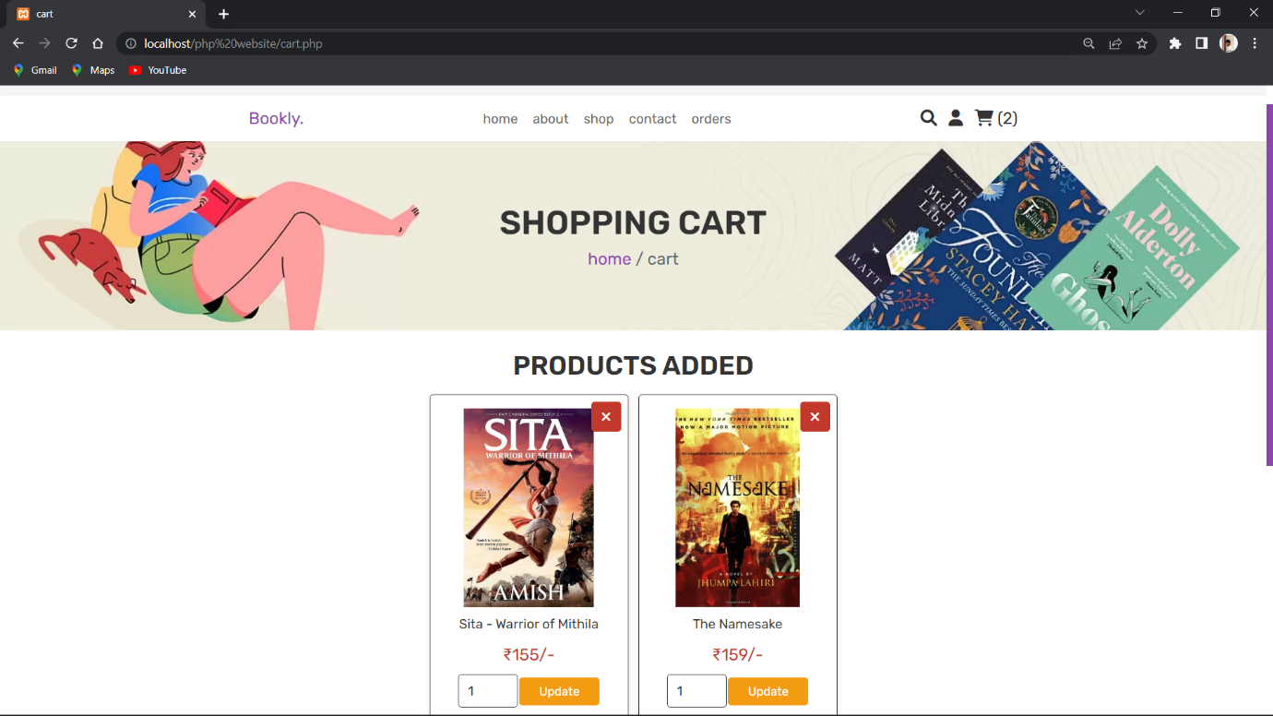

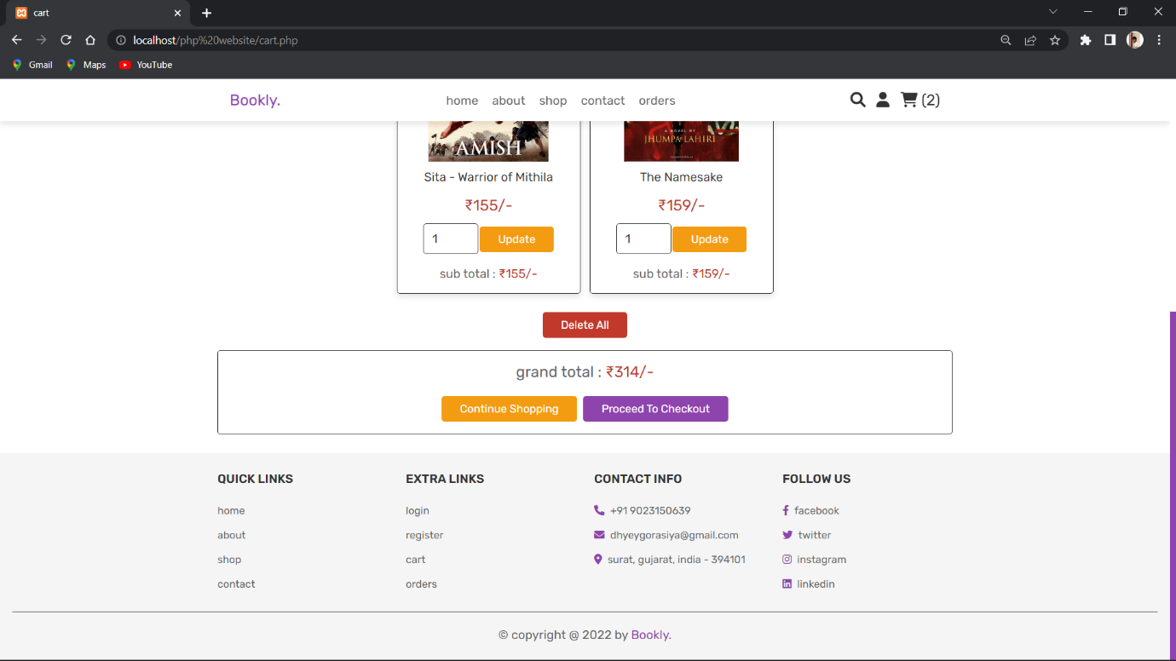

**CheckOut**

**<?php**

**include 'config.php';**

**session_start();**

**$user_id = $_SESSION['user_id'];**

**if(!isset($user_id)){**

**header('location:login.php');**

**}**

**if(isset($_POST['order_btn'])){**

**$name = mysqli_real_escape_string($conn, $_POST['name']);**

**$number = $_POST['number'];**

**$email = mysqli_real_escape_string($conn, $_POST['email']);**

**$method = mysqli_real_escape_string($conn, $_POST['method']);**

**$address = mysqli_real_escape_string($conn, 'flat no. '. $_POST['flat'].', '. $_POST['street'].', '. $_POST['city'].', '. $_POST['country'].' - '. $_POST['pin_code']);**

**$placed_on = date('d-M-Y');**

**$cart_total = 0;**

**$cart_products[] = '';**

**$cart_query = mysqli_query($conn, "SELECT * FROM `cart` WHERE user_id = '$user_id'") or die('query failed');**

**if(mysqli_num_rows($cart_query) > 0){**

**while($cart_item = mysqli_fetch_assoc($cart_query)){**

**$cart_products[] = $cart_item['name'].' ('.$cart_item['quantity'].') ';**

**$sub_total = ($cart_item['price'] * $cart_item['quantity']);**

**$cart_total += $sub_total;**

**}**

**}**

**$total_products = implode(', ',$cart_products);**

**$order_query = mysqli_query($conn, "SELECT * FROM `orders` WHERE name = '$name' AND number = '$number' AND email = '$email' AND method = '$method' AND address = '$address' AND total_products = '$total_products' AND total_price = '$cart_total'") or die('query failed');**

**if($cart_total == 0){**

**$message[] = 'your cart is empty';**

**}else{**

**if(mysqli_num_rows($order_query) > 0){**

**$message[] = 'order already placed!';**

**}else{**

**mysqli_query($conn, "INSERT INTO `orders`(user_id, name, number, email, method, address, total_products, total_price, placed_on) VALUES('$user_id', '$name', '$number', '$email', '$method', '$address', '$total_products', '$cart_total', '$placed_on')") or die('query failed');**

**$message[] = 'order placed successfully!';**

**mysqli_query($conn, "DELETE FROM `cart` WHERE user_id = '$user_id'") or die('query failed');**

**}**

**}**

**}**

**?>**

**<!DOCTYPE html>**

**……….**

**<?php**

**$grand_total = 0;**

**$select_cart = mysqli_query($conn, "SELECT * FROM `cart` WHERE user_id = '$user_id'") or die('query failed');**

**if(mysqli_num_rows($select_cart) > 0){**

**while($fetch_cart = mysqli_fetch_assoc($select_cart)){**

**$total_price = ($fetch_cart['price'] * $fetch_cart['quantity']);**

**$grand_total += $total_price;**

**?>**

**<p> <?php echo $fetch_cart['name']; ?> <span>(<?php echo '₹'.$fetch_cart['price'].'/-'.' x '. $fetch_cart['quantity']; ?>)</span> </p>**

**<?php**

**}**

**}else{**

**echo '<p class="empty">your cart is empty</p>';**

**}**

**?>**

**</html>**

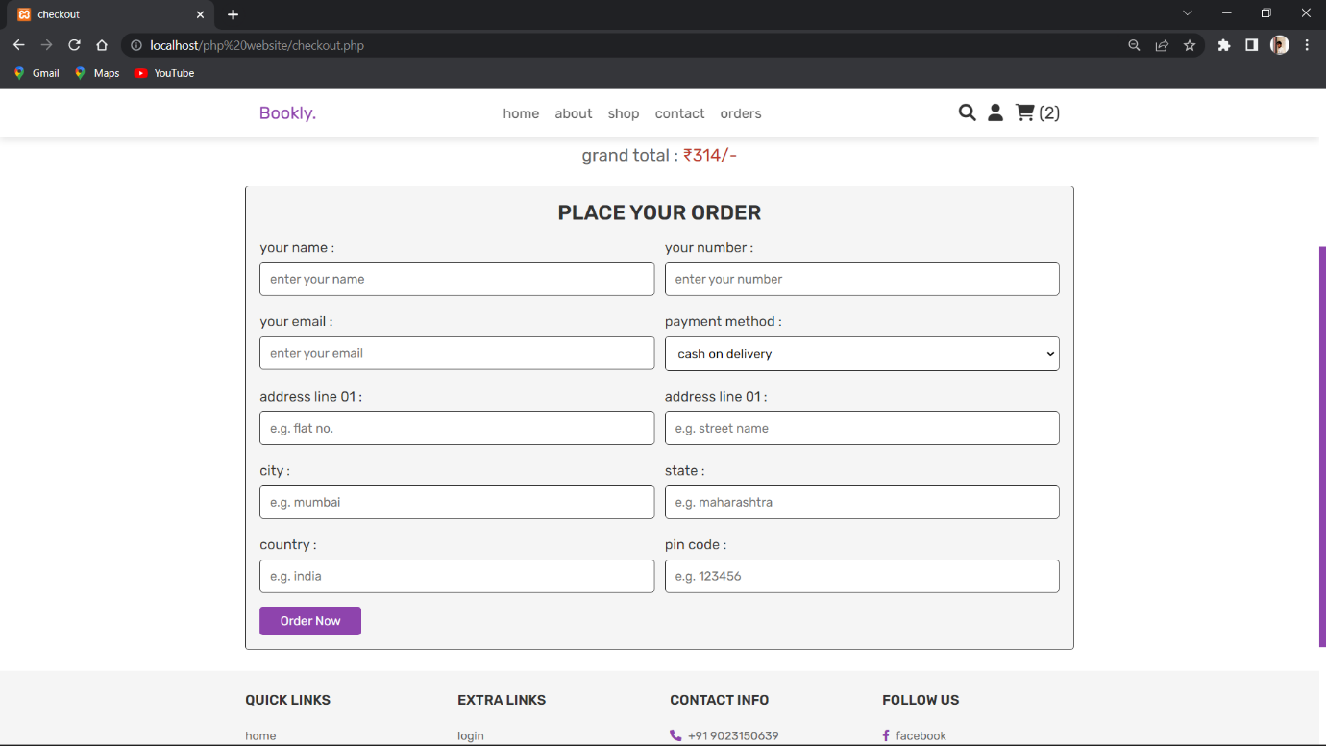

**Admin Side**

**Dashboard**

**<?php**

**include 'config.php';**

**session_start();**

**$admin_id = $_SESSION['admin_id'];**

**if(!isset($admin_id)){**

**header('location:login.php');**

**}**

**?>**

**<!DOCTYPE html>**

**……..**

**<?php include 'admin_header.php'; ?>**

**<!-- admin dashboard section starts -->**

**<?php**

**$total_pendings = 0;**

**$select_pending = mysqli_query($conn, "SELECT total_price FROM `orders` WHERE payment_status = 'pending'") or die('query failed');**

**if(mysqli_num_rows($select_pending) > 0){**

**while($fetch_pendings = mysqli_fetch_assoc($select_pending)){**

**$total_price = $fetch_pendings['total_price'];**

**$total_pendings += $total_price;**

**};**

**};**

**?>**

**<h3>₹<?php echo $total_pendings; ?>/-</h3>**

**<?php**

**$total_completed = 0;**

**$select_completed = mysqli_query($conn, "SELECT total_price FROM `orders` WHERE payment_status = 'completed'") or die('query failed');**

**if(mysqli_num_rows($select_completed) > 0){**

**while($fetch_completed = mysqli_fetch_assoc($select_completed)){**

**$total_price = $fetch_completed['total_price'];**

**$total_completed += $total_price;**

**};**

**};**

**?>**

**<h3>₹<?php echo $total_completed; ?>/-</h3>**

**<?php**

**$select_orders = mysqli_query($conn, "SELECT * FROM `orders`") or die('query failed');**

**$number_of_orders = mysqli_num_rows($select_orders);**

**?>**

**<h3><?php echo $number_of_orders; ?></h3>**

**<?php**

**$select_products = mysqli_query($conn, "SELECT * FROM `products`") or die('query failed');**

**$number_of_products = mysqli_num_rows($select_products);**

**?>**

**<h3><?php echo $number_of_products; ?></h3>**

**<?php**

**$select_users = mysqli_query($conn, "SELECT * FROM `users` WHERE user_type = 'user'") or die('query failed');**

**$number_of_users = mysqli_num_rows($select_users);**

**?>**

**<h3><?php echo $number_of_users; ?></h3>**

**<?php**

**$select_admins = mysqli_query($conn, "SELECT * FROM `users` WHERE user_type = 'admin'") or die('query failed');**

**$number_of_admins = mysqli_num_rows($select_admins);**

**?>**

**<h3><?php echo $number_of_admins; ?></h3>**

**<?php**

**$select_account = mysqli_query($conn, "SELECT * FROM `users`") or die('query failed');**

**$number_of_account = mysqli_num_rows($select_account);**

**?>**

**<?php**

**$select_messages = mysqli_query($conn, "SELECT * FROM `message`") or die('query failed');**

**$number_of_messages = mysqli_num_rows($select_messages);**

**?>**

**<!-- admin dashboard section ends -->**

**</html>**

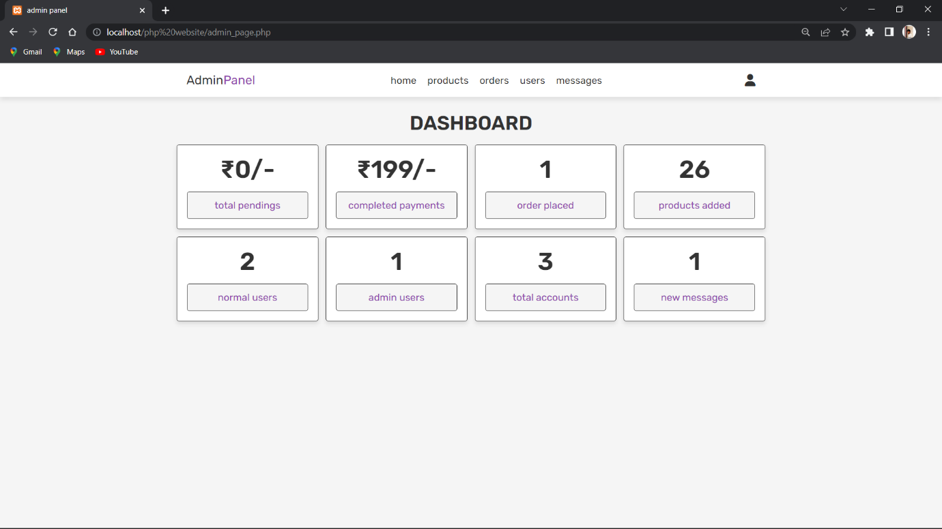

**Products**

**<?php**

**include 'config.php';**

**session_start();**

**$admin_id = $_SESSION['admin_id'];**

**if(!isset($admin_id)){**

**header('location:login.php');**

**};**

**if(isset($_POST['add_product'])){**

**$name = mysqli_real_escape_string($conn, $_POST['name']);**

**$price = $_POST['price'];**

**$image = $_FILES['image']['name'];**

**$image_size = $_FILES['image']['size'];**

**$image_tmp_name = $_FILES['image']['tmp_name'];**

**$image_folder = 'uploaded_img/'.$image;**

**$select_product_name = mysqli_query($conn, "SELECT name FROM `products` WHERE name = '$name'") or die('query failed');**

**if(mysqli_num_rows($select_product_name) > 0){**

**$message[] = 'product name already added';**

**}else{**

**$add_product_query = mysqli_query($conn, "INSERT INTO `products`(name, price, image) VALUES('$name', '$price', '$image')") or die('query failed');**

**if($add_product_query){**

**if($image_size > 2000000){**

**$message[] = 'image size is too large';**

**}else{**

**move_uploaded_file($image_tmp_name, $image_folder);**

**$message[] = 'product added successfully!';**

**}**

**}else{**

**$message[] = 'product could not be added!';**

**}**

**}**

**}**

**if(isset($_GET['delete'])){**

**$delete_id = $_GET['delete'];**

**$delete_image_query = mysqli_query($conn, "SELECT image FROM `products` WHERE id = '$delete_id'") or die('query failed');**

**$fetch_delete_image = mysqli_fetch_assoc($delete_image_query);**

**unlink('uploaded_img/'.$fetch_delete_image['image']);**

**mysqli_query($conn, "DELETE FROM `products` WHERE id = '$delete_id'") or die('query failed');**

**header('location:admin_products.php');**

**}**

**if(isset($_POST['update_product'])){**

**$update_p_id = $_POST['update_p_id'];**

**$update_name = $_POST['update_name'];**

**$update_price = $_POST['update_price'];**

**mysqli_query($conn, "UPDATE `products` SET name = '$update_name', price = '$update_price' WHERE id = '$update_p_id'") or die('query failed');**

**$update_image = $_FILES['update_image']['name'];**

**$update_image_tmp_name = $_FILES['update_image']['tmp_name'];**

**$update_image_size = $_FILES['update_image']['size'];**

**$update_folder = 'uploaded_img/'.$update_image;**

**$update_old_image = $_POST['update_old_image'];**

**if(!empty($update_image)){**

**if($update_image_size > 2000000){**

**$message[] = 'image file size is too large';**

**}else{**

**mysqli_query($conn, "UPDATE `products` SET image = '$update_image' WHERE id = '$update_p_id'") or die('query failed');**

**move_uploaded_file($update_image_tmp_name, $update_folder);**

**unlink('uploaded_img/'.$update_old_image);**

**}**

**}**

**header('location:admin_products.php');**

**}**

**?>**

**<!DOCTYPE html>**

**………**

**<?php**

**$select_products = mysqli_query($conn, "SELECT * FROM `products`") or die('query failed');**

**if(mysqli_num_rows($select_products) > 0){**

**while($fetch_products = mysqli_fetch_assoc($select_products)){**

**?>**

**<?php**

**}**

**}else{**

**echo '<p class="empty">no products added yet!</p>';**

**}**

**?>**

**<?php**

**if(isset($_GET['update'])){**

**$update_id = $_GET['update'];**

**$update_query = mysqli_query($conn, "SELECT * FROM `products` WHERE id = '$update_id'") or die('query failed');**

**if(mysqli_num_rows($update_query) > 0){**

**while($fetch_update = mysqli_fetch_assoc($update_query)){**

**?>**

**<input type="hidden" name="update_p_id" value="<?php echo $fetch_update['id']; ?>">**

**<input type="hidden" name="update_old_image" value="<?php echo $fetch_update['image']; ?>">**

**<img src="uploaded_img/<?php echo $fetch_update['image']; ?>" alt="">**

**<input type="text" name="update_name" value="<?php echo $fetch_update['name']; ?>" class="box" required placeholder="enter product name">**

**<input type="number" name="update_price" value="<?php echo $fetch_update['price']; ?>" min="0" class="box" required placeholder="enter product price">**

**<input type="file" class="box" name="update_image" accept="image/jpg, image/jpeg, image/png">**

**<input type="submit" value="update" name="update_product" class="btn">**

**<input type="reset" value="cancel" id="close-update" class="option-btn">**

**</form>**

**<?php**

**}**

**}**

**}else{**

**echo '<script>document.querySelector(".edit-product-form").style.display = "none";</script>';**

**}**

**?>**

**……….**

**</html>**

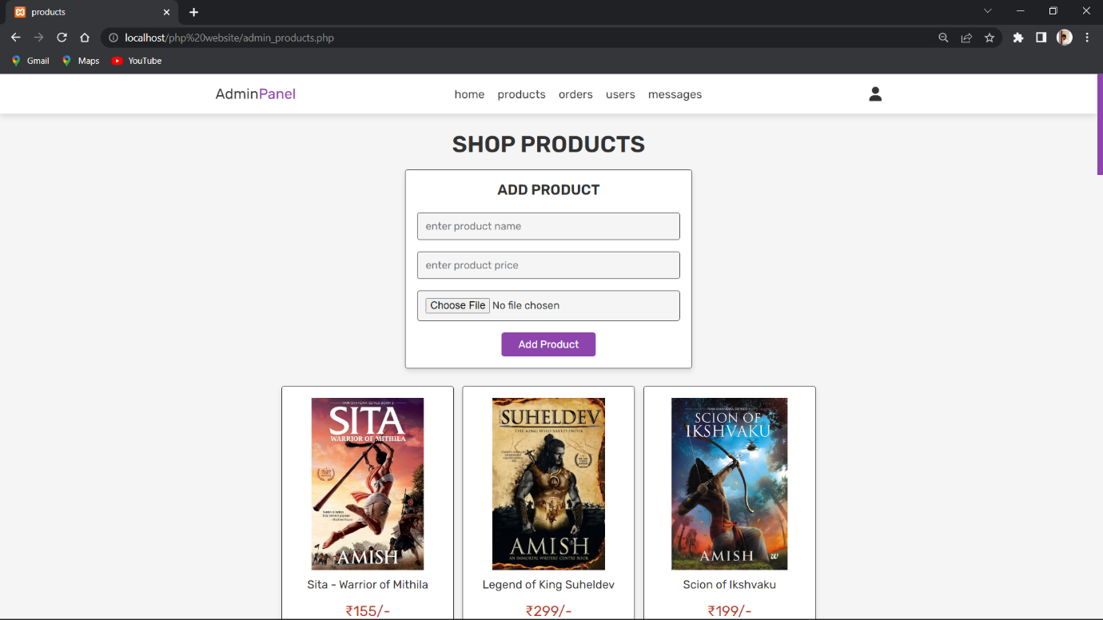

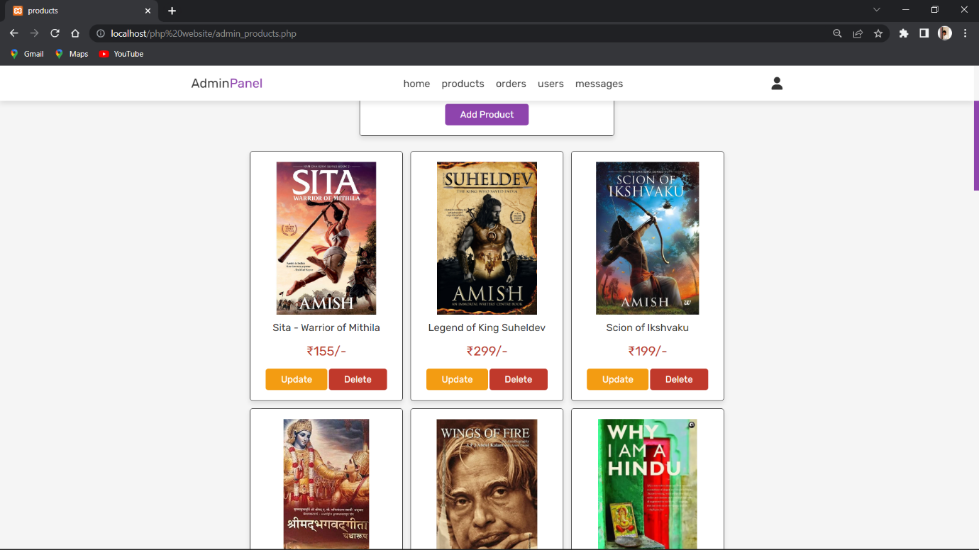

**Orders**

**<?php**

**include 'config.php';**

**session_start();**

**$admin_id = $_SESSION['admin_id'];**

**if(!isset($admin_id)){**

**header('location:login.php');**

**}**

**if(isset($_POST['update_order'])){**

**$order_update_id = $_POST['order_id'];**

**$update_payment = $_POST['update_payment'];**

**mysqli_query($conn, "UPDATE `orders` SET payment_status = '$update_payment' WHERE id = '$order_update_id'") or die('query failed');**

**$message[] = 'payment status has been updated!';**

**}**

**if(isset($_GET['delete'])){**

**$delete_id = $_GET['delete'];**

**mysqli_query($conn, "DELETE FROM `orders` WHERE id = '$delete_id'") or die('query failed');**

**header('location:admin_orders.php');**

**}**

**?>**

**<!DOCTYPE html>**

**……….**

**<?php**

**$select_orders = mysqli_query($conn, "SELECT * FROM `orders`") or die('query failed');**

**if(mysqli_num_rows($select_orders) > 0){**

**while($fetch_orders = mysqli_fetch_assoc($select_orders)){**

**?>**

**<div class="box">**

**<p> user id : <span><?php echo $fetch_orders['user_id']; ?></span> </p>**

**<p> placed on : <span><?php echo $fetch_orders['placed_on']; ?></span> </p>**

**<p> name : <span><?php echo $fetch_orders['name']; ?></span> </p>**

**<p> number : <span><?php echo $fetch_orders['number']; ?></span> </p>**

**<p> email : <span><?php echo $fetch_orders['email']; ?></span> </p>**

**<p> address : <span><?php echo $fetch_orders['address']; ?></span> </p>**

**<p> total products : <span><?php echo $fetch_orders['total_products']; ?></span> </p>**

**<p> total price : <span>₹<?php echo $fetch_orders['total_price']; ?>/-</span> </p>**

**<p> payment method : <span><?php echo $fetch_orders['method']; ?></span> </p>**

**<form action="" method="post">**

**<input type="hidden" name="order_id" value="<?php echo $fetch_orders['id']; ?>">**

**<select name="update_payment">**

**<option value="" selected disabled><?php echo $fetch_orders['payment_status']; ?></option>**

**<option value="pending">pending</option>**

**<option value="completed">completed</option>**

**</select>**

**<input type="submit" value="update" name="update_order" class="option-btn">**

**<a href="admin_orders.php?delete=<?php echo $fetch_orders['id']; ?>" onclick="return confirm('delete this order?');" class="delete-btn">delete</a>**

**</form>**

**</div>**

**<?php**

**}**

**}else{**

**echo '<p class="empty">no orders placed yet!</p>';**

**}**

**?>**

**……….**

**</html>**

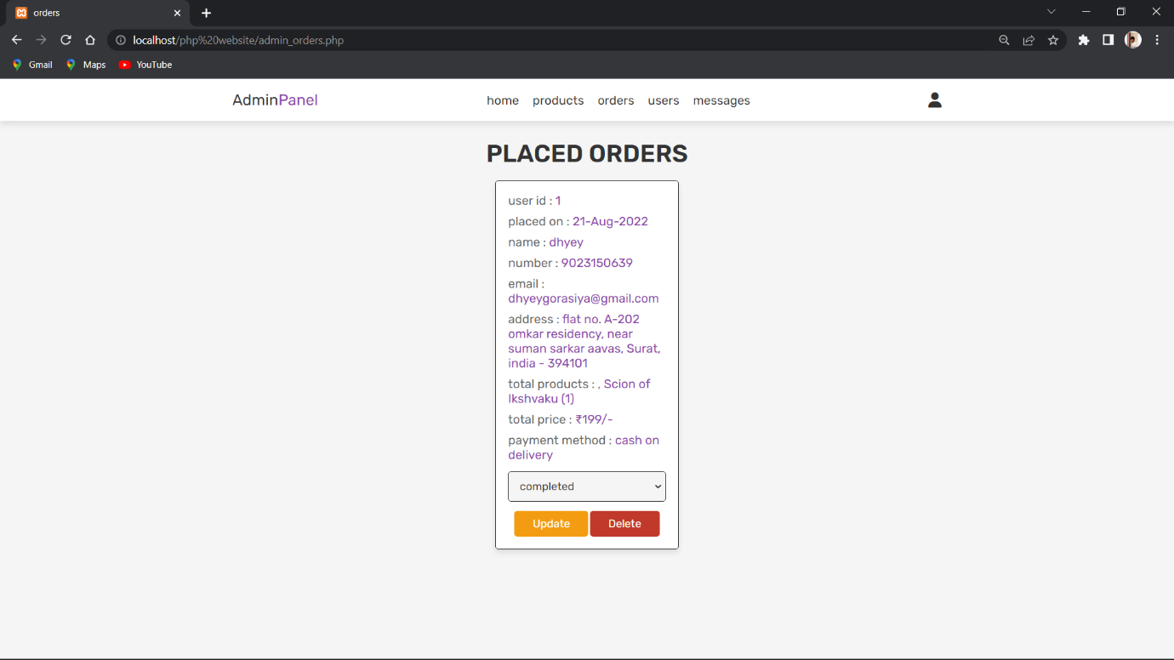

**Users**

**<?php**

**include 'config.php';**

**session_start();**

**$admin_id = $_SESSION['admin_id'];**

**if(!isset($admin_id)){**

**header('location:login.php');**

**}**

**if(isset($_GET['delete'])){**

**$delete_id = $_GET['delete'];**

**mysqli_query($conn, "DELETE FROM `users` WHERE id = '$delete_id'") or die('query failed');**

**header('location:admin_users.php');**

**}**

**?>**

**<!DOCTYPE html>**

**……….**

**<?php**

**$select_users = mysqli_query($conn, "SELECT * FROM `users`") or die('query failed');**

**while($fetch_users = mysqli_fetch_assoc($select_users)){**

**?>**

**<div class="box">**

**<p> user id : <span><?php echo $fetch_users['id']; ?></span> </p>**

**<p> username : <span><?php echo $fetch_users['name']; ?></span> </p>**

**<p> email : <span><?php echo $fetch_users['email']; ?></span> </p>**

**<p> user type : <span style="color:<?php if($fetch_users['user_type'] == 'admin'){ echo 'var(--orange)'; } ?>"><?php echo $fetch_users['user_type']; ?></span> </p>**

**<a href="admin_users.php?delete=<?php echo $fetch_users['id']; ?>" onclick="return confirm('delete this user?');" class="delete-btn">delete user</a>**

**</div>**

**?>**

**…………**

**</html>**

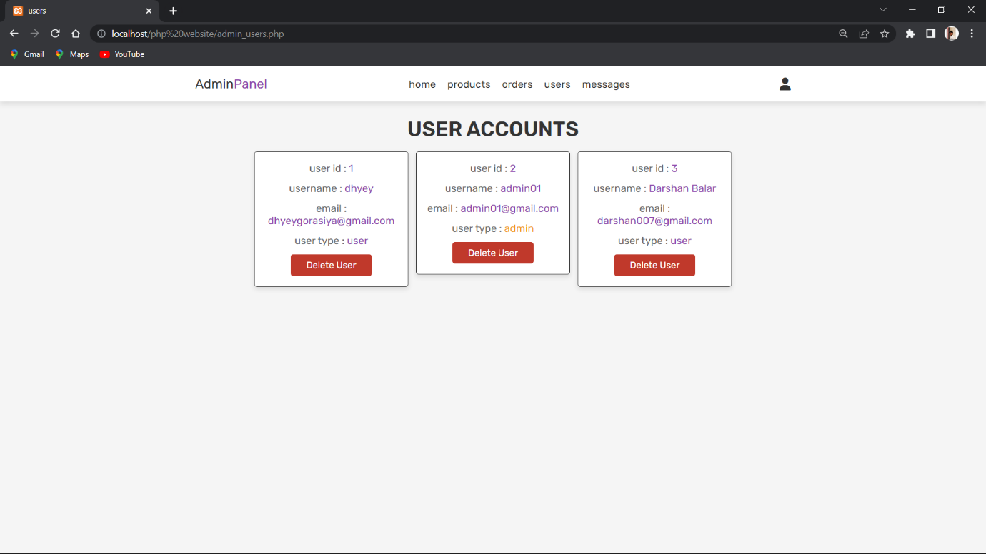

**Messages**

**<?php**

**include 'config.php';**

**session_start();**

**$admin_id = $_SESSION['admin_id'];**

**if(!isset($admin_id)){**

**header('location:login.php');**

**};**

**if(isset($_GET['delete'])){**

**$delete_id = $_GET['delete'];**

**mysqli_query($conn, "DELETE FROM `message` WHERE id = '$delete_id'") or die('query failed');**

**header('location:admin_contacts.php');**

**}**

**?>**

**<!DOCTYPE html>**

**……….**

**<?php**

**$select_message = mysqli_query($conn, "SELECT * FROM `message`") or die('query failed');**

**if(mysqli_num_rows($select_message) > 0){**

**while($fetch_message = mysqli_fetch_assoc($select_message)){**

**?>**

**<div class="box">**

**<p> user id : <span><?php echo $fetch_message['user_id']; ?></span> </p>**

**<p> name : <span><?php echo $fetch_message['name']; ?></span> </p>**

**<p> number : <span><?php echo $fetch_message['number']; ?></span> </p>**

**<p> email : <span><?php echo $fetch_message['email']; ?></span> </p>**

**<p> message : <span><?php echo $fetch_message['message']; ?></span> </p>**

**<a href="admin_contacts.php?delete=<?php echo $fetch_message['id']; ?>" onclick="return confirm('delete this message?');" class="delete-btn">delete message</a>**

**</div>**

**<?php**

**};**

**}else{**

**echo '<p class="empty">you have no messages!</p>';**

**}**

**?>**

**……….**

**</html>**

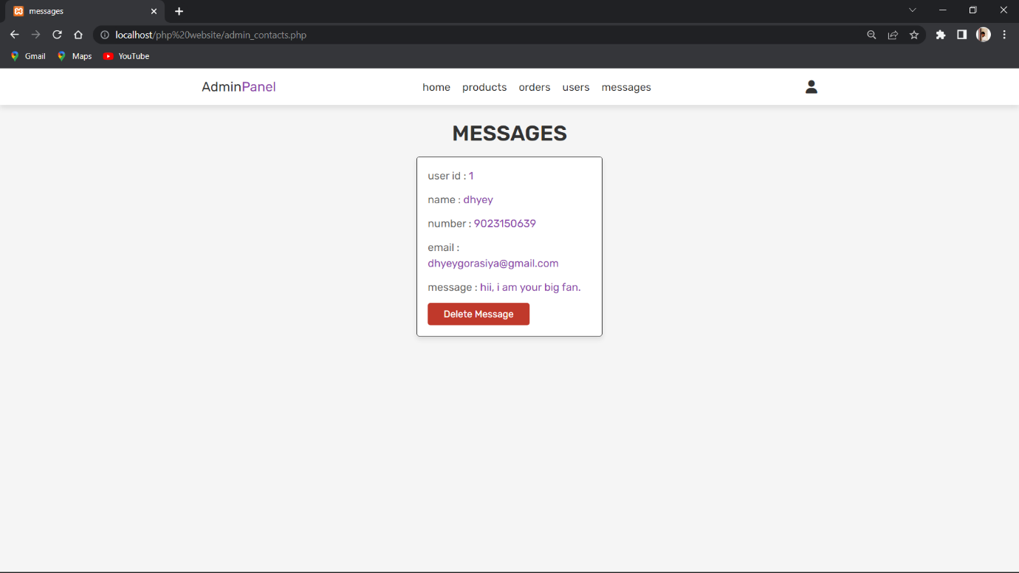

*THE END…*